## SYSTEM DESIGN

###### INPUT DESIGN

Input design is the process of converting user-originated inputs to a computer- based format. Input design is one of the most expensive phases of the operation of computerized system and is often the major problem of a system.

In the project, the input design is made in various web forms with various methods. For example, in the user creation form, the empty username and password is not allowed. The username if exists in the database, the input is considered to be invalid and is not accepted. Likewise, during the login process, the username is a must and must be available in the user list in the database. Then only login is allowed.

Input form are Login

User Registration

###### OUTPUT DESIGN

Output design generally refers to the results and information that are generated by the system for many end-users; output is the main reason for developing the system and the basis on which they evaluate the usefulness of the application.

.

Output forms are, View page Weblog

###### DATABASE DESIGN

The database design is a must for any application developed especially more for the data store projects. Since the chatting method involves storing the message in the table and produced to the sender and receiver, proper handling of the table is a must. In the project, login table is designed to be unique in accepting the username and the length of the username and password should be greater than zero. The different users view the data in different format according to the privileges given.

Login table

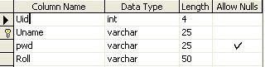

Temp data

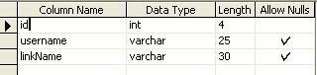

Data

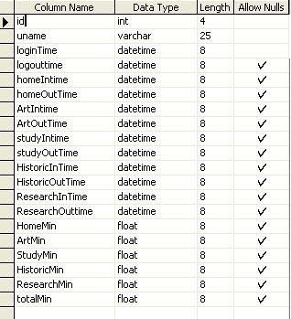

User information

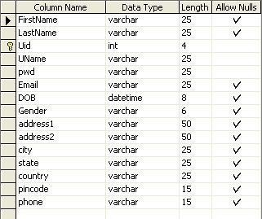

Favorite



favorTemp

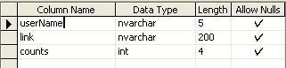

**DATA FLOW DIAGRAMS: LEVEL-0:**

Uid, pwd

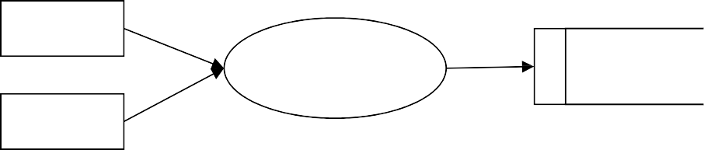

Admin

User

browsing

Database

User

Uid, pwd

Store

Retrieve

**LEVEL-1:**

Uid, pwd Uid, pwd

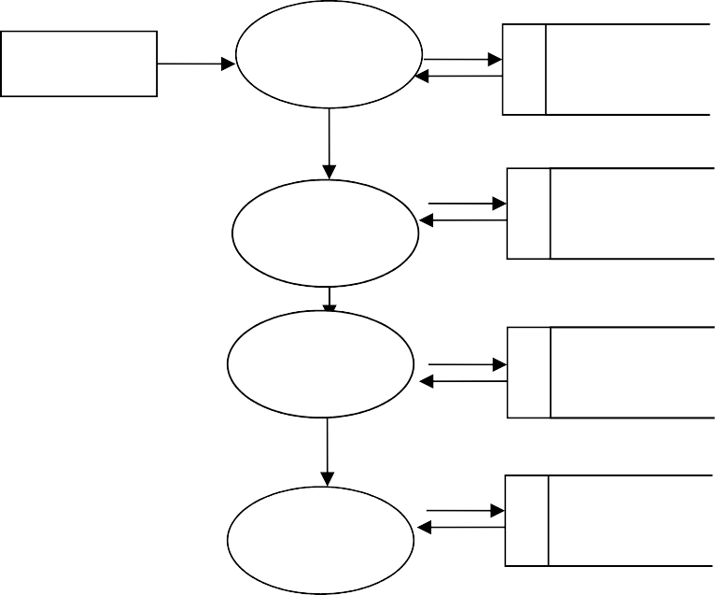

Admin

Login

Admin

cid, name, addr

User

User

information

Date, time, count

Browser

Data

information

uid, Date, time,

Data

User

**LEVEL-2:**

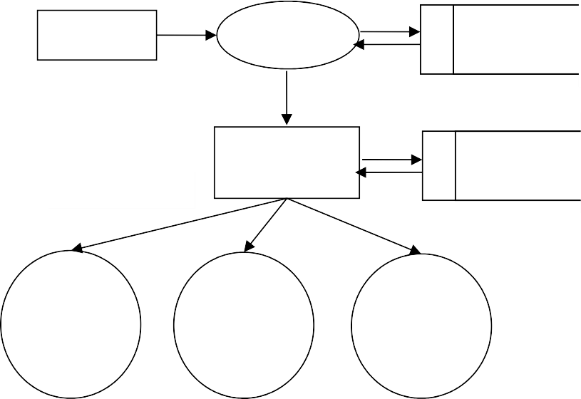Admin Login Admin

uid, pwd

uid, addr, name

Browser History view

Data information

link name, count

User wise view

Time Wise View

Link Wise View

date/time

**LEVEL-3:**

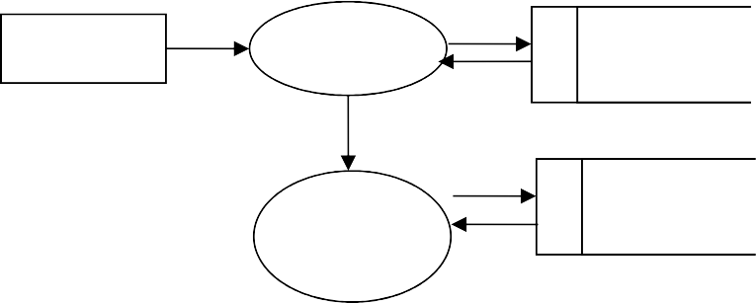

User

Login

User

uid, pwd

Link

Details

Data

information

link name, count

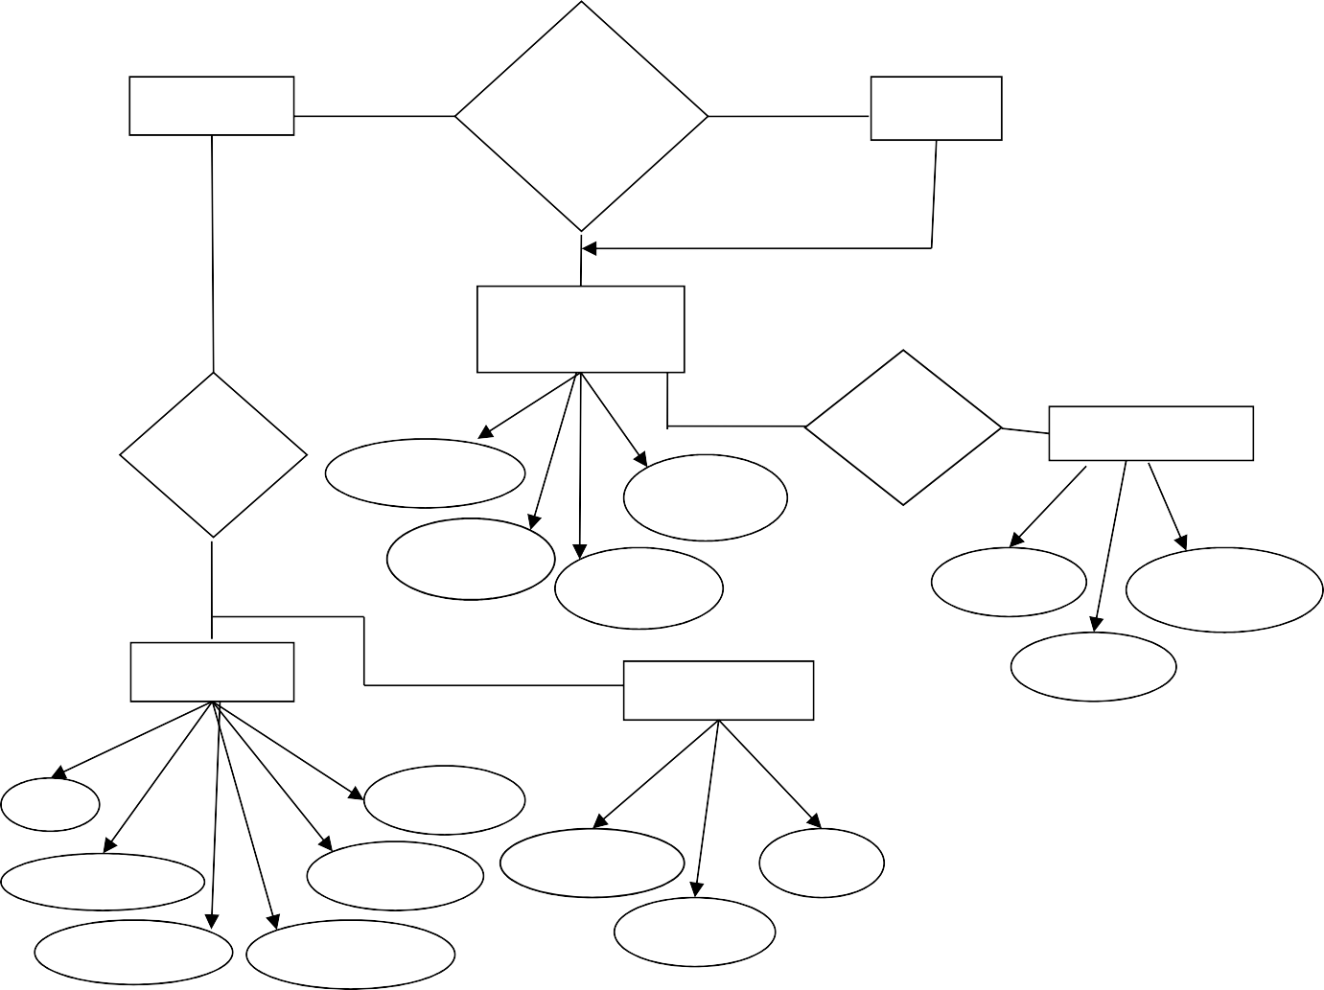

**Admin**

**User Browsing Behavior Analysis**

**User**

**Registration**

**Vie**

**w**

Uname

**User**

**Login**

**Login**

Addres

Uid

Pwd

Uid

Uname

**Data**

**FavorTemp**

Pwd

Id

Uname

logintime

totalmi

usernam

link

logouttim

historicmi

count

**ER Diagram:**